How to set up Sample Application from Avery Dennison Android SDK package.

1. Copy the SampleApplication folder from the package in your workspace.
2. Start the Android Studio and choose the “Import Project (Eclipse, ADT, Gradle etc.)” option.

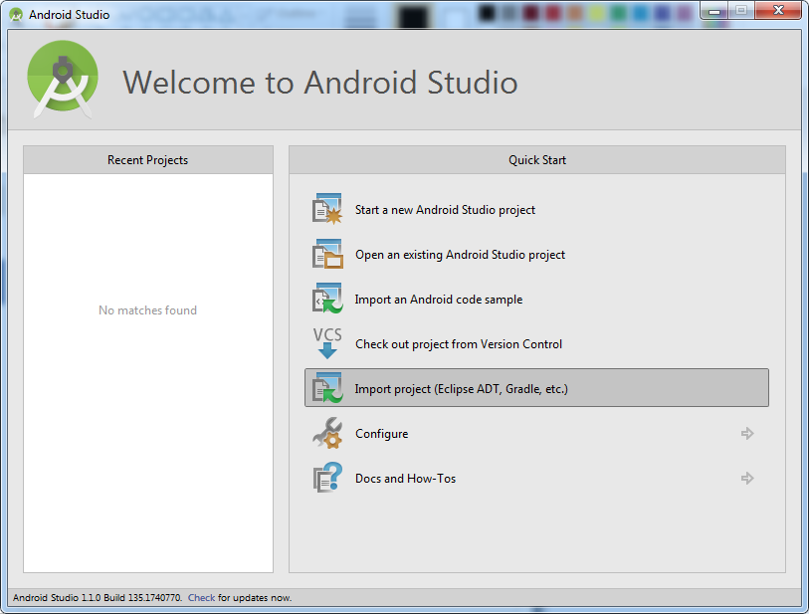

1. Find the SampleApplication folder in your workspace. Choose the “build.gradle” script in it, next to “SampleApp” folder (but not the “build.gradle” script in the “SampleApp” folder!)

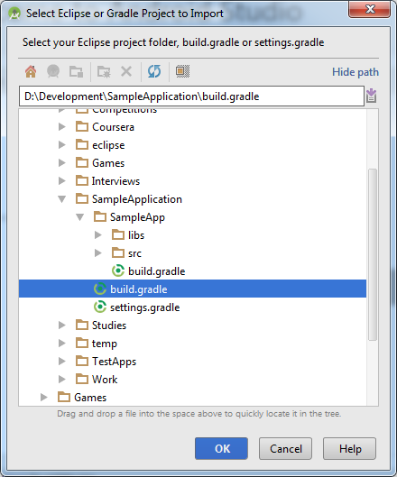

1. Configure the Gradle settings for this project by clicking “Yes” in the next dialog.

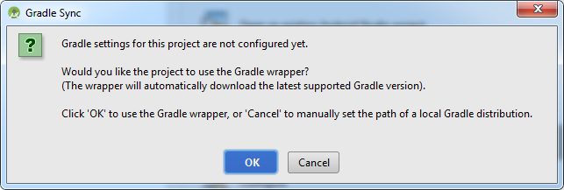

1. Your project should be imported properly after these actions and ready to be built and run on the Android devices. One of the most frequent errors that may occur after importing is that your Android Studio may lack the appropriate Android SDK version. In that case, either install missing SDK or open “build.gradle” script inside the “SampleApp” folder and change the targetSdkVersion and compileSdkVersion to the version of SDK that you have (you can check that in Android SDK Manager), then press “Try Again” option on the bar displaying an error to recompile the Gradle build script.

